**Real-Time River Water Quality Monitoring and Control System**

**INTRODUCTION**

The environment around consists of five key elements e.g., soil, water, climate , natural vegetation, and landforms. Among these water is the utmost crucial element for human life. It is also vital for the persistence of other living habitats [1]. Whether it is used for drinking, domestic use, and food production or recreational purposes, safe and readily available water is the need for public health [2]. So it is highly imperative for us to maintain water quality balance. Otherwise, it would severely damage the health of the humans and at the same time affect the ecological balance among other species [3]. Water pollution is a foremost global problem which needs ongoing evaluation and adaptation of water resource directorial principle at the levels of international down to individual wells. It has been studied that water pollution is the leading cause of mortalities and diseases worldwide. The records show that more than 14,000 people die daily worldwide due to water pollution. In many developing countries, dirty or contaminated water is being used for drinking without any proper prior treatment

1.1 PROJECT OVERVIEW

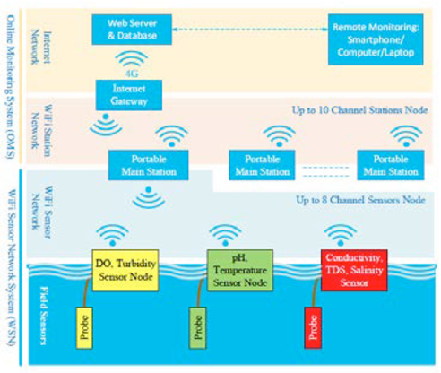

1.2 PURPOSE

The main aim is to develop a system for continuous monitoring of river water quality at remote places using wireless sensor networks with low power consumption, low-cost and high detection accuracy. pH, conductivity, turbidity level,etc.

**LITERATURE SURVEY**

1) IoT Based Real-time River Water Quality Monitoring System Mohammad Salah UddinChowdury, Talha BinEmran, Science Direct – 2018 This paper proposes a sensor-based water quality monitoring system. The main components of Wireless Sensor Network (WSN) include a microcontroller for processing the system, communication system for inter and intra node communication and several sensors. Real-time data access can be done by using remote monitoring and Internet of Things (IoT) technology.

2) Review of Water Quality Monitoring using Internet of Things (IoT) Mr. A. P. Roger Rozario, R. Surya IEEE, 2019 The quality of the water must be monitored in real-time to ensure its safety and supply. Monitoring water in traditional ways takes longer, which can take up to from 24 to 96 hours to identify contaminants in water supplies, which are more time taking. This project aims at developing a water quality monitoring system using sensors and IoT (Internet of Things). The water quality parameters like temperature, pH, and turbidity are measures using sensors and the water quality index is determined. The measured values from the sensors will be processed using a microcontroller, and alert message will be sent to the user via an android application developed using MIT app inventor in case of any abnormalities.

3) A Development and Implementation of Water Quality Assessment Monitoring (WQAM) System using the Internet of Things (IoT) in Water Environment Muhammad Farhan Johan, S. Abdullah, A. Zanal Saurabh S. Soman, Hamidreza Zareipour , Om Malik JEVA , 23 November 2021 This paper presents the development and implementation of Water Quality Assessment and Monitoring (WQAM) system. The system development used Wi-Fi enabled microcontroller to connect with the IoT environment and store the data in the IoT cloud server. The microcontroller used is Arduino UNO that interacts with three types of sensor probes which are pH, turbidity and temperature probe. All the data measurements is transferred using a Wi-Fi module which is ESP8266. The IoT cloud used to utilize the data frame is Thing Speak. This system was implemented on Bandar Pereda Lake and Deraa River in Pulao Pinang with two systems implemented at each location. The sensors were placed on the water surface for more accurate measurements. This system continuously measures the readings of pH, turbidity dan temperature on the lake/river for every 1 hour. Twenty readings were taken for every 1 hour within the first 20 minutes with 1 minute interval and the readings were stored in the IoT cloud server.

2.1 EXISTING PROBLEM

The system is less effective as sensors are installed very deep inside the water and their positions are fixed. The sensors are very expensive. Moreover their maintenance cost is also very high.

2.2 REFERENCES

Central Pollution Control Board (2013) Status of water quality in India 2011. Central Pollution Control Board, New Delhi Central Water Commission Ministry of Water Resources India (2014) Report on Krishna River Basin Version 2.0 Geetha S, Gouthami S (2016) Internet of things enabled real time water quality monitoring system.

Smart Water 2:1. https://doi. org/10.1186/s40713-017-0005-y Herojeet R, Rishi MS, Lata R, Sharma R (2016) Application of environmetrics statistical models and water quality index for groundwater quality characterization of alluvial aquifer of Nalagarh Valley, Himachal Pradesh, India. Sustain Water Resour Manag 2:39–53. https://doi.org/10.1007/s40899-015-0039-y

2.3 PROBLEM STATEMENT DEFINITION

(PS) I am (Customer) I’m trying to But Because Which makes me feel PS-1 As a soft drink manufacturer, I struggle with the problems caused by the river that served as my source of water. I’m attempting to reduce my water filtration procedure by getting clean and quality river water for my products However, I’m unable to succeed since I haven’t found a suitable alternative to manual labour or a workable solution Because the filtration procedure is more timeconsuming with poor water quality, we are unable to produce the best product possible. It is one of the obstacles to the success of my firm and makes me responsible for customer happiness.

PS-2 I’m a Limnologists In order to do my research for my current thesis on river water managemen t and its effects on ecosystems, I must evaluate the river's water quality. But each time I require informatio n about river water quality for analysis, I have to do it by hand, since I haven't discovered a good replaceme nt to the manual way. Because, I can't do my task on time since evaluating the river water quality takes additional time. It gives me the impression that, in order to finish my thesis quickly, I need an automated river water managemen t and control system that will allow me to use the data it generates for my research.

**IDEATION & PROPOSED SOLUTION**

3.1 EMPATHY MAP CANVAS

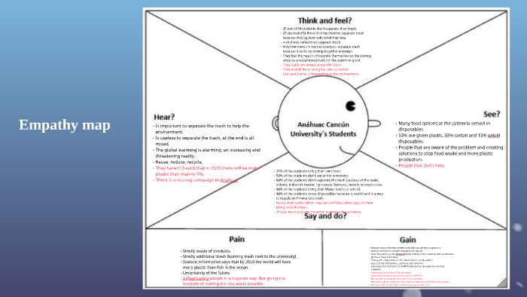

3.2 IDEATION & BRAINSTORMING

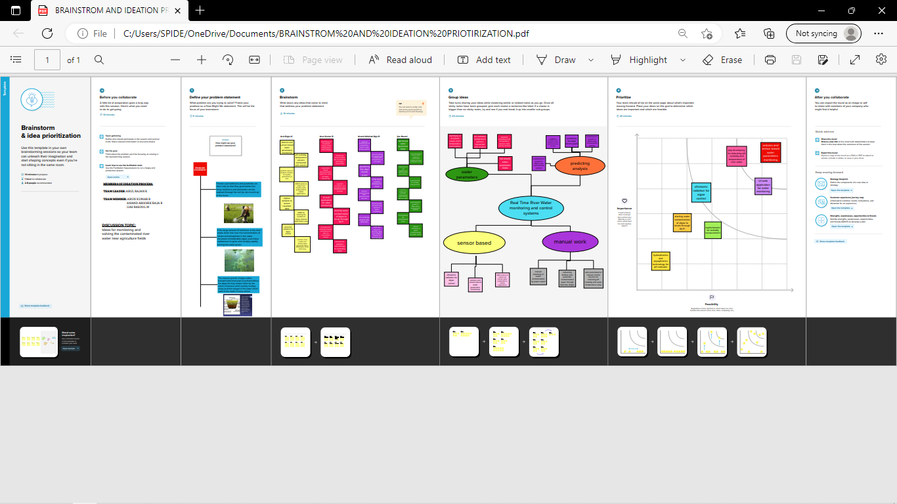

3.3 PROPOSED SOLUTION

|  |  |  |
| --- | --- | --- |
| **S.No.** | **Parameter** | **Description** |
| 1. | Problem Statement (Problem to besolved) | Massive growth of algae called eutrophication leads to pollution(monitoring and controlling the quality of river water) |
| 2. | Idea / Solution description | Detecting the dust particles , PH level of water, Dissolved oxygen and temperature to be monitored and altering the authorities if water quality is not good. |
| 3. | Novelty / Uniqueness | River water quality can be monitored by web application.  Quality parameter will track continuously with standard measurements. |
| 4. | Social Impact / Customer Satisfaction | Localities will not get suffered by poor quality of water by alerting them when the water quality is not good. |
| 5. | Business Model (Revenue Model) | Water quality monitoring system by aeron systems for industrial water treatment plant, river bodies, aqua forming ,digital loggers. |
| 6. | Scalability of the Solution | Measuring of real time values and continuous monitoring helps in maintaining the quality of water. |

3.4 PROBLEM SOLUTION FIT

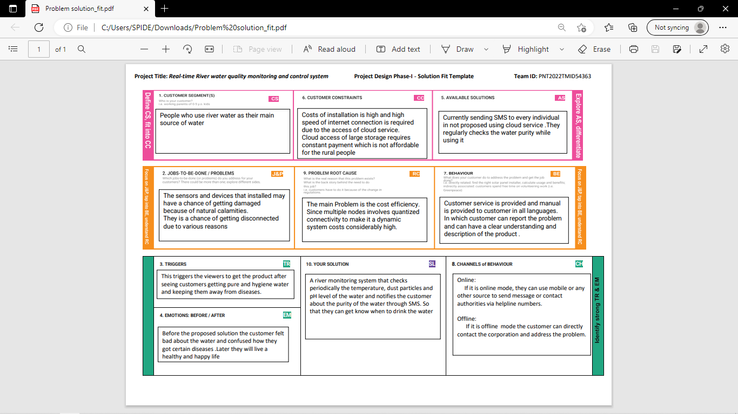

**REQUIREMENT ANALYSIS**

4.1 FUNCTIONAL REQUIRMENT

An Arduino mega is utilized as a core person. The Arduino victimized here is mega 2560 because multiple analog sign sensors probe requisite to be conterminous with the Arduino inhabit. It has a set of registers that use as a solon use RAM. Specific intend to know registers for on-chip component resources are also mapped into the assemblage grapheme. The addressability of store varies depending on instrumentation series and all PIC devices someone several banking mechanisms to utilise addressing to additional faculty. Subsequent series of devices have move instructions which can covert move had to be achieved via the register. Thus the mechanism functions with the exploit of coding intrinsically in the Arduino UNO R3 skate.

4.2 NON -FUNTIONAL REQUIREMENTS

The quality parameters are labeled datasets including desired outputs of specific combination of inputs. The neural network will produce output to classify water quality as dangerous, be careful, and good. The classification layer will run on top of Hadoop cluster [17]. The advantages of using neural network based analytics are like Artificial Neural Networks (ANNs) are good in learning and modeling non-linear relationships, and high volatile data [18]. Though neural networks are prone to over fitting, the neural network model used in water quality monitoring system is not complex enough to cause over fitting problem.

**ADVANTAGES**

Monitoring is necessary to ensure that our waters can continue to support the many different ways we use these resources and to track whether protection and restoration measures are working.

**DISADVANTAGES**

The system is less effective as sensors are installed very deep inside the water and their positions are fixed. The sensors are very expensive. Moreover their maintenance cost is also very high.

**CONCLUSION**

Real-time monitoring of water quality by using IoT integrated Big Data Analytics will immensely help people to become conscious against using contaminated water as well as to stop polluting the water. The research is conducted focusing on monitoring river water quality in real-time. Therefore, IoT integrated big data analytics is appeared to be a better solution as reliability, scalability, speed, and persistence can be provided. During the project development phase an intense comparative analysis of real-time analytics technologies such as Spark streaming analysis through Spark MLlib, Deep learning neural network models, and Belief Rule Based (BRB) system will be conducted [20- 27]. This research would recommend conducting systematic experimentation of the proposed technologies in diverse qualities of river water in Bangladesh.

**FUTURE SCOPE**

Due to the limitation of the budget, we only focus on measuring the quality of river water parameters. This project can be extended into an efficient water management system of a local area. Moreover, other parameters which wasn’t the scope of this project such as total dissolved solid, chemical oxygen demand and dissolved oxygen can also be quantified. So the additional budget is required for further improvement of the overall system.

**APPENDIX**

SOURCE CODE

|  |  |
| --- | --- |
| import serial |  |
|  | import time |
|  | import csv |
|  | import numpy as np |
|  | import matplotlib.pyplot as plt |
|  | ser = serial.Serial('/COM6',9600) |
|  | ser_bytes = ser.readline(10) |
|  | print (ser_bytes) |
|  | ser.flushInput() |
|  | while True: |
|  | try: |
|  | ser_bytes = ser.readline() |
|  | decoded_bytes = float(ser_bytes[0:len(ser_bytes)-2].decode("utf-8")) |
|  | print(decoded_bytes) |
|  | temp = float(decoded_bytes(1:3)) |
|  | turb = float(decoded_bytes(4:6)) |
|  | pH = float(decoded_bytes(6:8)) |
|  | with open("test_data.csv","a") as f: |
|  | writer = csv.writer(f,delimiter=",") |
|  | writer.writerow([time.time(),decoded_bytes]) |
|  | except: |
|  | print("Keyboard Interrupt") |
|  | ser.close() |
|  | break() |
|  | t = np.arange(0.0, 2.0, 0.01) |
|  | s = 1 + np.sin(2*np.pi*t) |
|  | plt.plot(t, s) |
|  | plt.xlabel('time (s)') |
|  | plt.ylabel('Celsisus (C)') |
|  | plt.title('Temperature') |
|  | plt.grid(True) |
|  | plt.savefig("Temperature.png") |
|  | plt.show() |
|  | Serial.begin(9600); |
|  | sensors.begin(); |
|  | int sensorValue = analogRead(A1); |
|  | voltage = sensorValue * (5.0 / 1024.0); |
|  | } |
|  | void loop(void) |
|  | { |
|  | sensors.requestTemperatures(); |
|  | Celcius=sensors.getTempCByIndex(0); |
|  | Fahrenheit=sensors.toFahrenheit(Celcius); |
|  | for(int i=0;i<10;i++) |
|  | { |
|  | buf[i]=analogRead(analogInPin); |
|  | delay(10); |
|  | } |
|  | for(int i=0;i<9;i++) |
|  | { |
|  | for(int j=i+1;j<10;j++) |
|  | { |
|  | if(buf[i]>buf[j]) |
|  | { |
|  | temp=buf[i]; |
|  | buf[i]=buf[j]; |
|  | buf[j]=temp; |
|  | } |
|  | n = 256 |
|  | X = np.linspace(-np.pi, np.pi, 256, endpoint=True) |
|  | C,S = np.cos(X), np.sin(X) |
|  | plt.plot(X, C) |
|  | plt.plot(X,S) |
|  | plt.show() |
|  | print ("Visualization of real time sensor Data.") |
|  | print("/n") |
|  | while True: |
|  | try: |
|  | ser_bytes = ser.readline() |
|  | decoded_bytes = float(ser_bytes[0:len(ser_bytes)-2].decode("utf-8")) |
|  | print(decoded_bytes) |
|  | temp = float(decoded_bytes(1:3)) |
|  | turb = float(decoded_bytes(4:6)) |
|  | pH = float(decoded_bytes(6:8)) |
|  | with open("test_data.csv","a") as f: |
|  | writer = csv.writer(f,delimiter=",") |
|  | writer.writerow([time.time(),decoded_bytes]) |
|  | except: |
|  | print("Keyboard Interrupt") |
|  | ser.close() |
|  | break() |
|  | t = np.arange(0.0, 2.0, 0.01) |
|  | s = 1 + np.sin(2*np.pi*t) |
|  | plt.plot(t, s) |